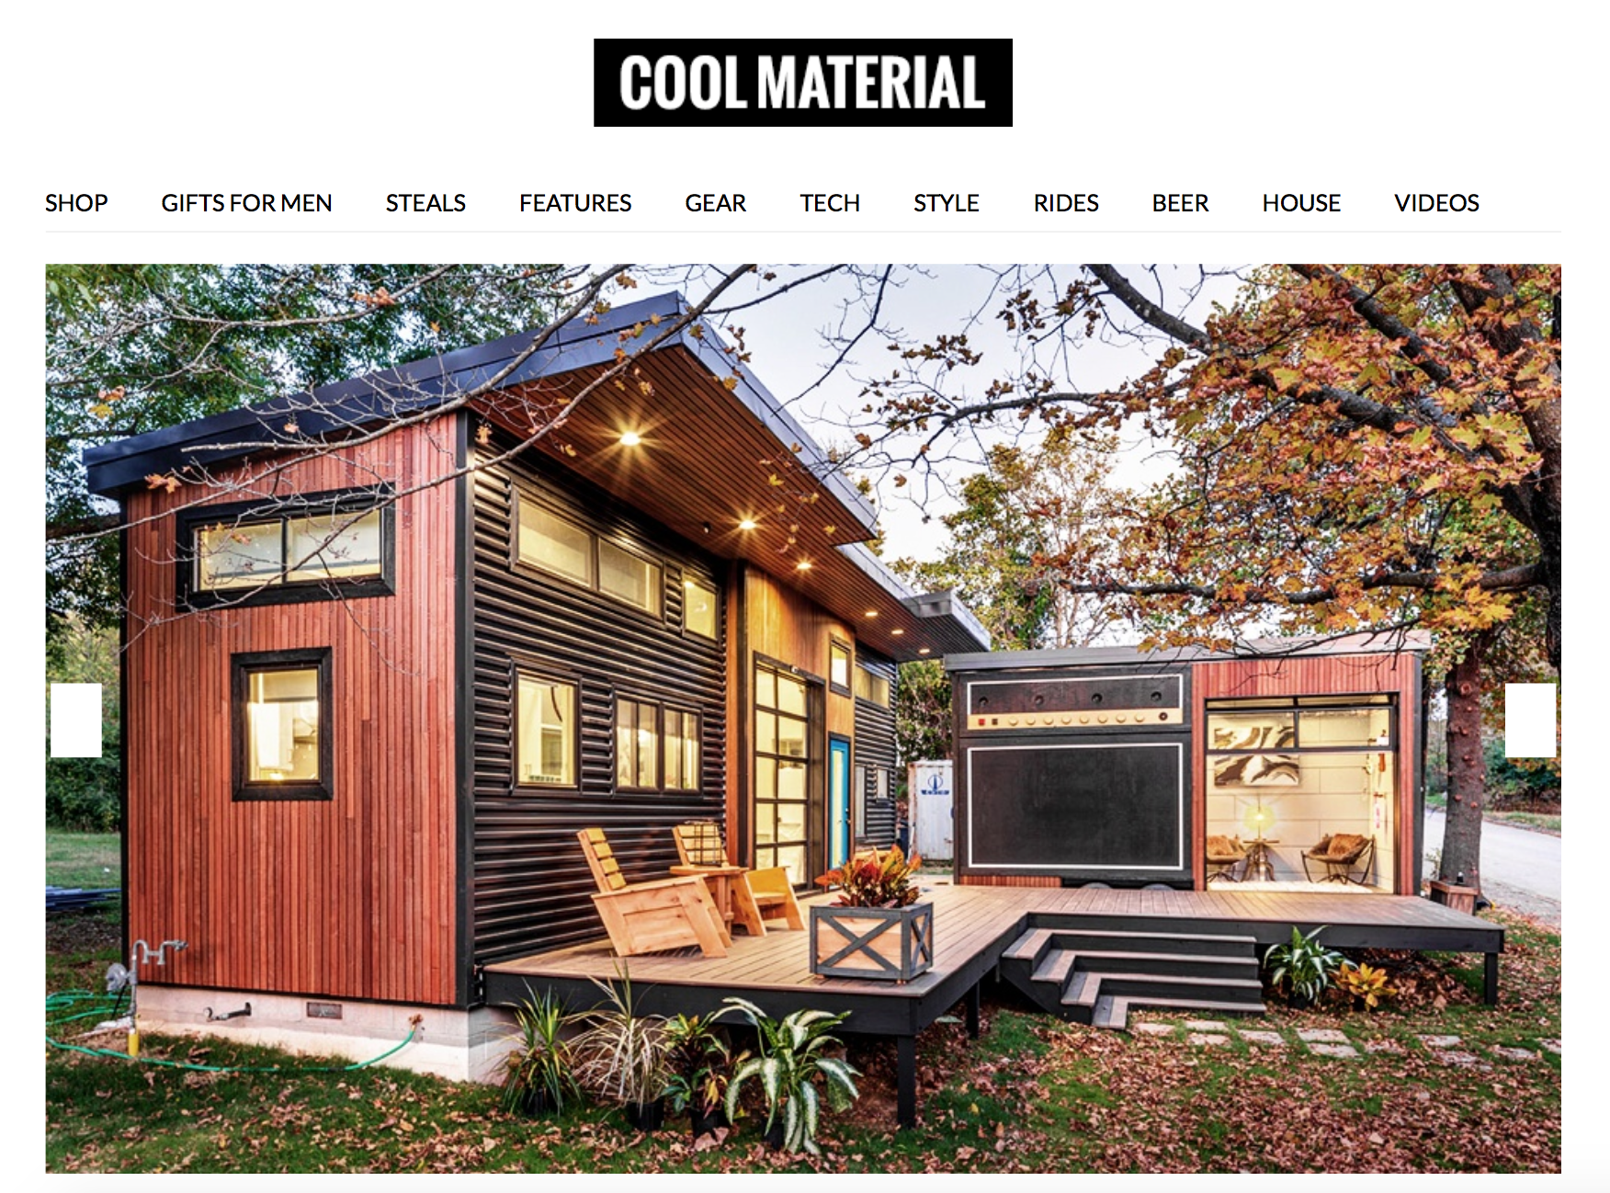

This Tiny House Has a Giant Amplifier

When electric violinist Asha Mevlana applied to be on Tiny House Nation we’re willing to bet she had no idea the final project would be like the “Amplified” Tiny House with a giant amplifier built into one of the buildings. Mevlana, who has worked with everyone from Mary J. Blige and Jay-Z to Alanis Morrisette and Gnarls Barkley, worked with family, friends and the network to create a split tiny house with a larger main building and a smaller building on a trailer that functions as music studio, guest quarters and traveling festival space. The two separate buildings are connected with a large wooden deck that’s great for parties and can double as a stage when her musician friends stop by. And while the main house with split stairs, bicycle wheel pots and pans pulley system, and coffee table entertainment center is great, it’s the giant amplifier built in the side of the trailer studio. That giant amp is made with a wall of boat speakers and is fully functional for that perfect combination of Back to the Future and Spinal Tap (yes, it goes to 11!).

Amplifier House | Cool Material , 3/20/17
http://coolmaterial.com/home/amplifier-house/
Author: Ben Dahl
More: Home, Architecture, Houses, Music

